**1)Print the Number 1 to 10 each number bring different colour.**

<DOCTYPE html>

<html>

<head>

<title>Lab 1st Program </title>

</head>

<body>

<h1>Number from 1 to 10 </h1>

<font Color="Blue"> 1 </font> </br>

<font Color="Pink"> 2 </font> </br>

<font Color="Purple"> 3 </font> </br>

<font Color="Black"> 4 </font> </br>

<font Color="Red"> 5 </font> </br>

<font Color="Sky Blue"> 6 </font> </br>

<font Color="Green"> 7 </font> </br>

<font Color="Orange"> 8 </font> </br>

<font Color="Brown"> 9 </font> </br>

<font Color="Maroon"> 10 </font> </br>

</body>

</html>

**Output:**

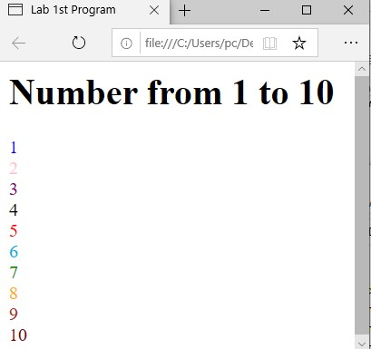

**2)Write a html program to display 4th time table using colspan and rowspan.**

<html>

<head>

<title>Time table</title>

</head>

<body>

<h1>BCA 4th Sem time table </h1>

<table border ="1">

<tr>

<th>Day</th>

<th>9:30-10:25</th>

<th>10:25-11:20</th>

<th>11:20-11:30</th>

<th>11:30-12:25</th>

<th>12:25-1:20</th>

<th>1:20-2:00</th>

<th>2:00-2:55</th>

<th>2:25-3:50</th>

</tr>

<tr>

<td>Monday</td>

<td>Eng</td>

<td>FA</td>

<td rowspan = "6">Short Break</td>

<td>MA</td>

<td>Python</td>

<td rowspan = "6">Lunch Break</td>

<td colspan = "2">Python/MA Lab</td>

</tr>

<tr>

<td>Tuesday</td>

<td>Python</td>

<td>BLS</td>

<td colspan = "2">Python/MA Lab</td>

<td>FA</td>

<td>Sports</td>

</tr>

<tr>

<td>Wednesday</td><td>IC</td>

<td>MA</td>

<td>BLS</td>

<td>Hin/Kann</td>

<td>FA</td>

<td>Activity</td>

</tr>

<tr>

<td>Thursday</td>

<td>Python</td>

<td>Eng</td>

<td>MA</td>

<td>Hin/Kann</td>

<td colspan = "2">Python/MA Lab</td>

</tr>

<tr>

<td>Friday</td>

<td colspan = "2">IC</td>

<td>MA</td>

<td>Eng</td>

<td>Hin/Kann</td>

<td>Sports</td>

</tr>

<tr>

<td>Saturday</td>

<td>Eng</td>

<td>Python</td>

<td colspan = "2">Python/MA Lab</td>

</tr>

</table>

</body>

</html>

**Output:**

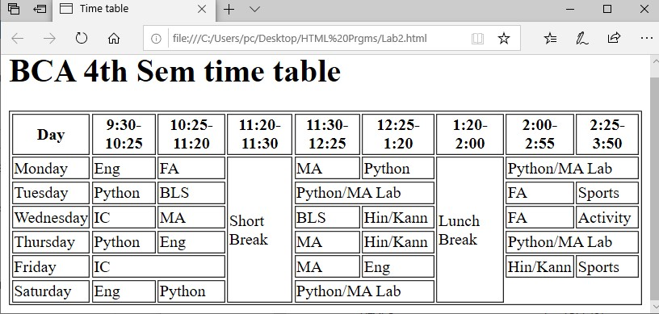

**3)Print the paragraph that is description of a book include the title of the book as well as its author and title should be underlined adjectives should etlic and bold.**

<html>

<head>

<title>HTML </title>

</head>

<body>

<h1> <u> Java Programming Language </u> </h1>

<h2> <u>Author name:Balaguruswamy </u> </h2>

<p>Java is Oriented Programming Language.It is simplest language,Java includes Objects and classes which is related to real world things also.Java Language can be used in real world.The basic concepts of Java programming <i><b>Object,Class,Inheritance,Encapsulation,Polymorphism </i></b>etc.Classes are the set of obejects.Encapsulation hides data and Polymorphism works multiple tasks at one time.It is simple and fimilar language for the user.</p>

</body>

</html>

**Output:**

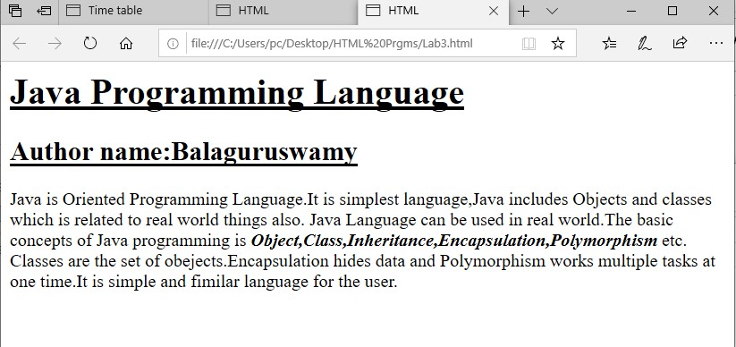

**4)Print the square of number 1 to 20 each number should be in separate line next too is number is super scripted and the equal sign and the result(10^2=100).**

<html>

<head>

<title>HTML</title>

</head>

<body>

<h1>Square of number 1 to 20 </h1>

1<sup>^</sup>2=1 </br>

2<sup>^</sup>2=4 </br>

3<sup>^</sup>2=9 </br>

4<sup>^</sup>2=16 </br>

5<sup>^</sup>2=25 </br>

6<sup>^</sup>2=36 </br>

7<sup>^</sup>2=49 </br>

8<sup>^</sup>2=64 </br>

9<sup>^</sup>2=81 </br>

10<sup>^</sup>2=100 </br>

11<sup>^</sup>2=121 </br>

12<sup>^</sup>2=144 </br>

13<sup>^</sup>2=169 </br>

14<sup>^</sup>2=196 </br>

15<sup>^</sup>2=225 </br>

16<sup>^</sup>2=256 </br>

17<sup>^</sup>2=289 </br>

18<sup>^</sup>2=324 </br>

19<sup>^</sup>2=361 </br>

20<sup>^</sup>2=400 </br>

</body>

</html>

**Output:**

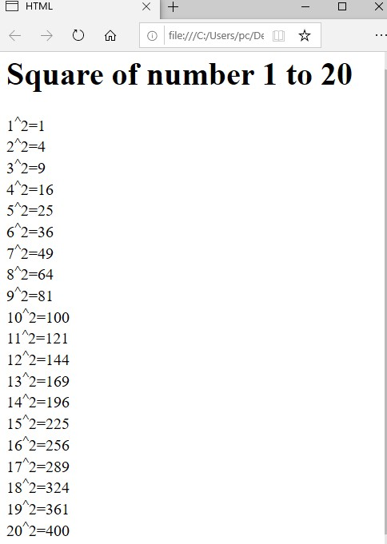

**5)Create links to five different pages on 5 different website that should all open in a new window.**

**Lab5.py:**

<html>

<head>

<title>Google Apps</title>

</head>

<body>

<a href="Google.html">Google</a>

<a href="Gmap.html">Gmap</a>

<a href="Gdrive.html">Gdrive</a>

<a href="Gmail.html">Gmail</a>

<a href="Gpay.html">Gpay</a>

</body>

</html>

**Google.html:**

<html>

<body>

<h1><u><b>Google</b></u></h1>

<p>The term google itself is a creative spelling of googol,<b>a number equal to 10 to 100th power,or more colloguially,an unfathomable number.</b>Googol was coined in the 1930s and is attributed to nine-year-old nephew of American mathematician Edward Kasner.<br>It is search for information about someone or somthing on the internet using the search engine google.</p> </body>

</html>

**Gmap.html:**

<html>

<body>

<h1><u><b>Gmap</b></u></h1>

<p>Gmap means <b>Google Maps</b>.Google maps provides a route planner,allowing users to find available directions through driving,public transperation,walking or biking.</p> </body>

</html>

**Gdrive.html:**

<html>

<body>

<h1><u><b>Gdrive</b></u></h1>

<p>Gdrive means <b>google drive.</b>With Google Drive,you can store your files securely and open or edit them from any device.Files you create with Google apps open in your browser or mobile app.Other types of files in your folder oprn in thier regular applications.</p>

</body>

</html>

**Gmail.html:**

<html>

<body>

<h1><u><b>Gmail</b></u></h1>

<p>Gmail is an abbreviation for Google Mail.Dependency.An email can never work without an Email client or an established paltform,like Yahoo,mail,Gmail,Hotmail,Mail.ru,etc.Gmail is one of the Email service providers that lets its users create a Google Account that has a usique Email ID associated with it.</p>

</body>

</html>

**Gpay.html:**

<html>

<body>

<h1><u><b>Gpay</b></u></h1>

<p>Gpay means <b>Google pay</b>.YOu can use the Google pay app to do things like:Make contactless payment.Buy items online or in apps.Send money to friends and family.</p> </body>

</html>

**Output:**

**Lab5.py:**

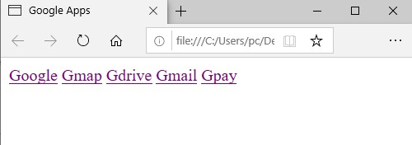

**1)Google.html:**

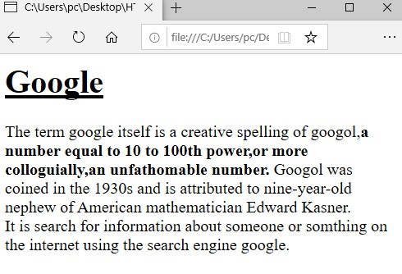

**2)Gmap.html:**

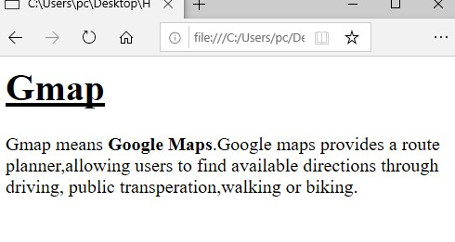

**3)Gdrive.html:**

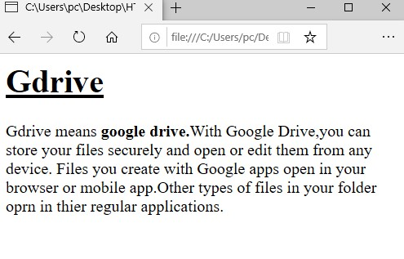

**4)Gmail.html:**

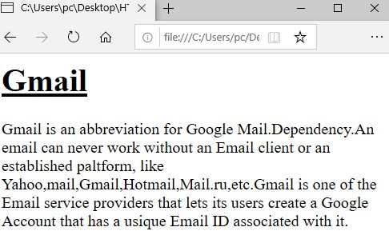

**5)Gpay.html:**

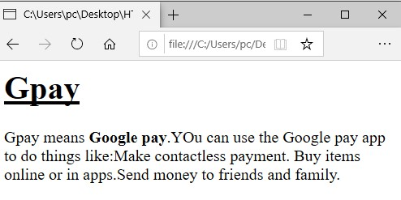

**7)Setting font type of text,Setting font size of text,Setting font color of text,Setting font Style of text.**

<DOCTYPE html>

<html>

<head> <style> p {

font-family:French Script MT; font-size:30px;

color:Blue;

font-Style:Italic;

}

</style>

</head>

<body>

<p>A CSS Selector is first part of CSS rule.It is a pattern of element and other terms.That tells the browser which html element should be selected to have the CSS property values.Inside the rule apply to them.The element or elements which are selected by the selector are reffered to as subject of the selector.</p>

</body>

</html>

**Output:**

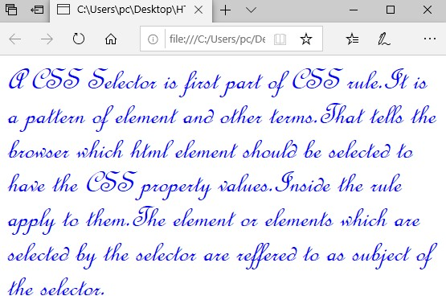

**6)Setting background image of a page and setting text background color using CSS.**

<html>

<head> <style>

body{

background-image:url(Flower.jpg); background-repeat:no-repeat;

background-size:cover;

background-color:grey;

}

h1{ color:yellow; font-style:italic;

}

</style>

</head>

<body>

<h1>Computer Multimedia and Animation</h1>

</body>

</html>

**Output:**

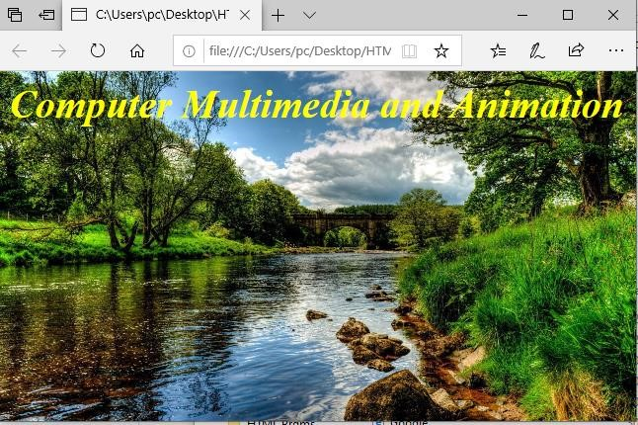

**10)write a Javascript to convert tempreture to and from celcius,Fahrenheit.**

<html>

<head>

<title>javascript program to convert temp</title>

<body>

<h1>temp convert F to C/C to F </h1>

<h4>F to C</h4>

<label for ="f">enter the value of Fahrenheit:</label>

<input type ="number" id="fah" placeholder="value of Fahrenheit"><br><br>

<button onClick="FtoC()">Convert</button>

<p>celcius:<span id="display"></span></p>

<h4>C to F</h4>

<label for ="c">enter the value of Celcius:</label>

<input type ="number" id="cel" placeholder="value of Celcius"><br><br>

<button onClick="CtoF()">Convert</button>

<p>fahrenheit:<span id="display2"></span></p>

<script type="text/Javascript">

function FtoC()

{

var f=parseInt(document.getElementById("fah").value); var celsius=(f-32)/1.8;

document.getElementById("display").innerHTML=celsius;

}

function CtoF()

{

var c=parseInt(document.getElementById("cel").value); var fahrenheit=(c*1.8)+32;

document.getElementById("display2").innerHTML=fahrenheit;

}

</script>

</head>

</body>

</html>

**Output:**

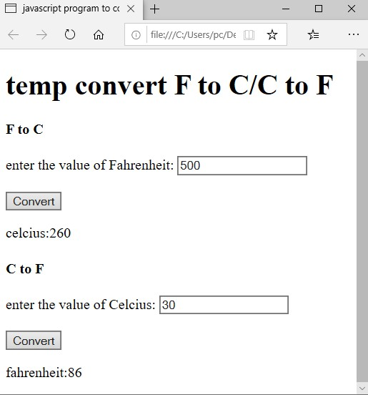

**8)Create a web page with two image alternatively change on mouse over using CSS.**

<!DOCTYPE html>

<head>

<title>Image Swap on Hover with CSS</title>

<style>

.img

{

width: 60px; height: 55px; position: relative; display: inline-block;

}

.img .img-top

{

display: none; position: absolute; top: 0;

left: 0;

z-index: 40;

}

.img:hover .img-top

{

display: inline;

}

</style>

</head>

<body>

<div class="img">

<img src="C:\Users\pc\Desktop\image\a99e34c48753fa2cf4dc04a6b01f746d.jpg" alt="img Back">

<img src="C:\Users\pc\Desktop\image\2b2b1110569856cc7b4962abf6695e9c.jpg" class="img-top" alt="img Front">

</div>

</body>

</html>

**Output:**

**Front**

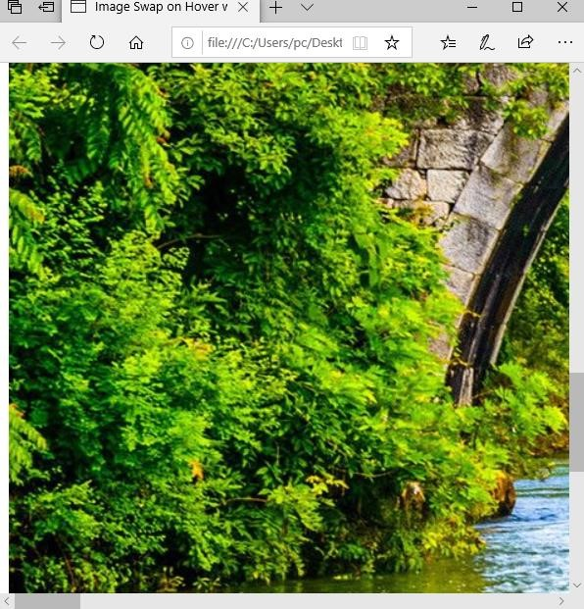

**Back**

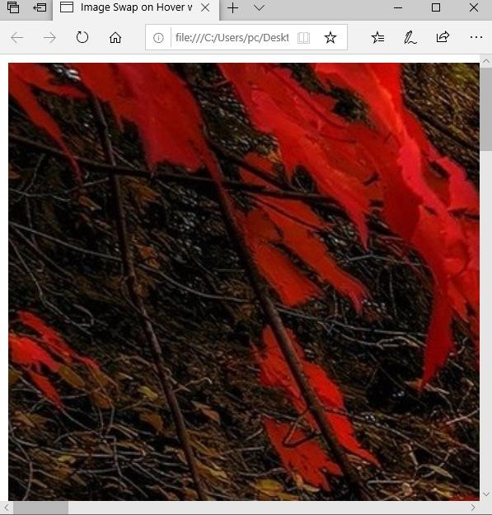

**11)Write a program to create line rect angle using SVG.**

<!DOCTYPE html>

<html>

<body>

<svg width="400" height="200">

<rect width="300" height="100" style="fill:Grey; stroke-width:3;stroke:black"/>

<line x1="0" y1="200" x2="200" y2="200" style="stroke:black; stroke-width=2"/>

</svg>

</body>

</html>

**Output:**

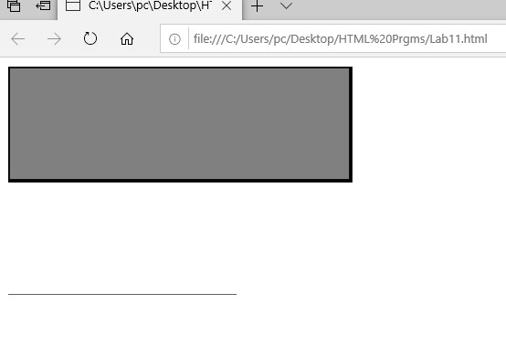

**12)Write program to create Polygon and Polyline.**

<!DOCTYPE html>

<html>

<head>

<title>polygon and polyline</title>

</head>

<body>

<h1>HTML5-Polygon and Polyline</h1>

<svg width="500" height="500">

<!--create a polygon with 5 points-->

<polygon points="100,100 150,50 200,100 200,200 100,200"stroke="black"stroke-width="2" fill="none"/>

<!--create a polyline with 4 points-->

<polyline points="300,100 350,50 400,100 400,200"stroke="red"stroke-width="4" fill="none"/> </svg>

</body>

</html>

**Output:**

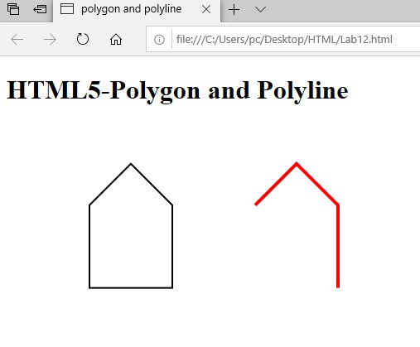

**9)Write a javascript to display current date and time.**

<!DOCTYPE html>

<html>

<body>

<h1>Javascript Day and Time</h1>

<p id="demo"></p>

<script>

const d=new Date();

document.getElementById("demo").innerHTML=d;

</script>

</body>

</html>

**Output:**

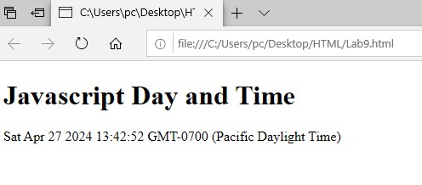

**14)Write a program to create line and rectangle using Canvas.**

<!DOCTYPE html>

<html>

<body>

<h1>HTML5 Canvas</h1>

<canvas id="myCanvas" width="500" height="300" style="border:1px solid blue"> </canvas>

<script>

const c=document.getElementById("myCanvas"); const ctx=c.getContext("2d");

ctx.beginPath();

ctx.moveTo(10,30);

ctx.lineTo(300,30);

ctx.rect(60,60,200,200);

ctx.fillStyle="pink";

ctx.fill(); ctx.strokeStyle="red";

ctx.stroke();

</script>

</body>

</html>

**Output:**

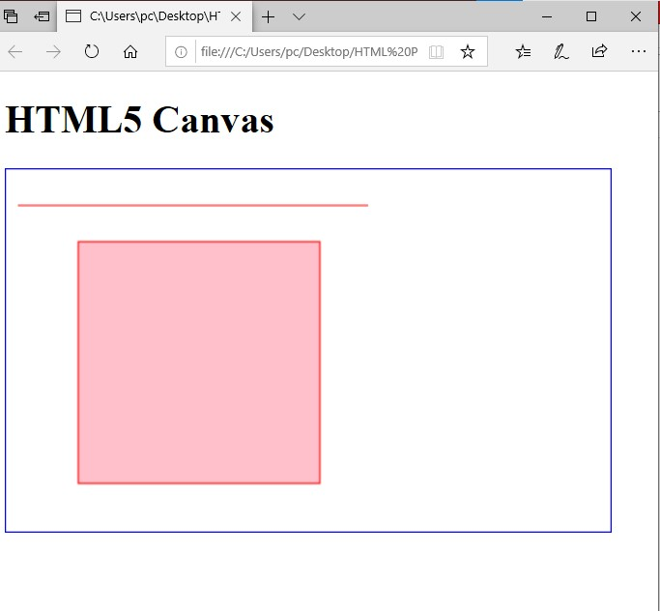

**15)Write a program to create Bezier Curves.**

<!DOCTYPE html>

<html>

<body>

<h1>HTML5 Canvas</h1>

<canvas id="myCanvas" width="300" height="200" style="border:1px solid blue;">

</canvas>

<script>

const canvas=document.getElementById("myCanvas"); const ctx=canvas.getContext("2d");

ctx.beginPath();

ctx.moveTo(20,20);

ctx.bezierCurveTo(20,100,200,100,200,20); ctx.stroke();

</script>

</body>

</html>

**Output:**

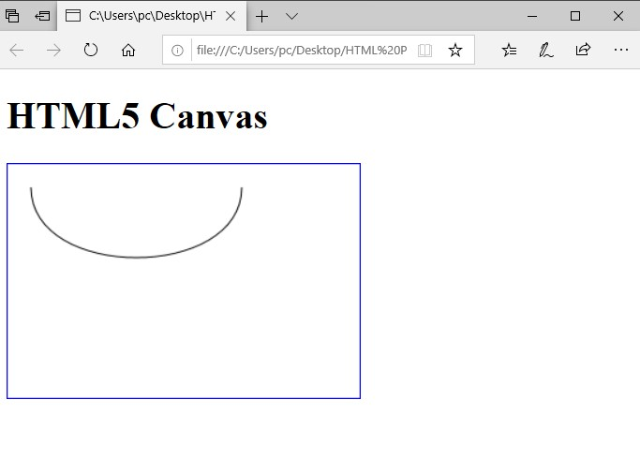

**16)Write a Program to create Linear Gradient.**

<html>

<body>

<canvas id="myCanvas" width="300" height="150" style="border:1px solid blue;"></canvas>

<script>

var c= document.getElementById("myCanvas");

var ctx = c.getContext("2d");

var grd= ctx.createLinearGradient(0,0,170,10);

grd.addColorStop(0,"pink");

grd.addColorStop(1,"blue");

ctx.fillStyle = grd;

ctx.fillRect(20,20,150,100);

</script>

</body>

</html>

**Output:**

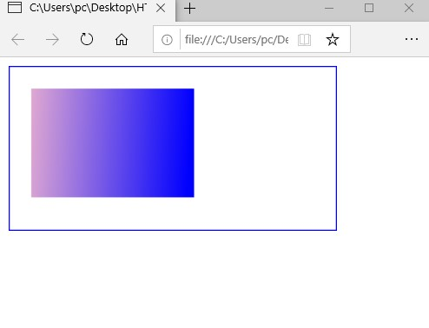

**20)Write a program to rotate a small image repeatedly.**

<!DOCTYPE html>

<html>

<head>

<title>Canvas Rotation Animation Example</title>

<style>

canvas{

border:1px solid black;

}

</style>

</head>

<body>

<canvas id="myCanvas" width="1000" height="1000"></canvas>

<script>

var canvas= document.getElementById("myCanvas");

var ctx=canvas.getContext("2d");

var image=new Image();

image.src="River.jpg";

image.onload=function(){

var angle=0;

var x=100;

var y=100;

setInterval(function(){

ctx.clearRect(0, 0, canvas.width, canvas.height); ctx.save();

ctx.translate(x + image.width / 2, y + image.height / 2); ctx.rotate(angle * Math.PI / 180);

ctx.drawImage(image, -image.width / 2, -image.height / 2);

ctx.restore(); angle+=1; if(angle >= 360): {

angle=0;

}

}, 10);

};

</script>

</body>

</html>

**Output:**

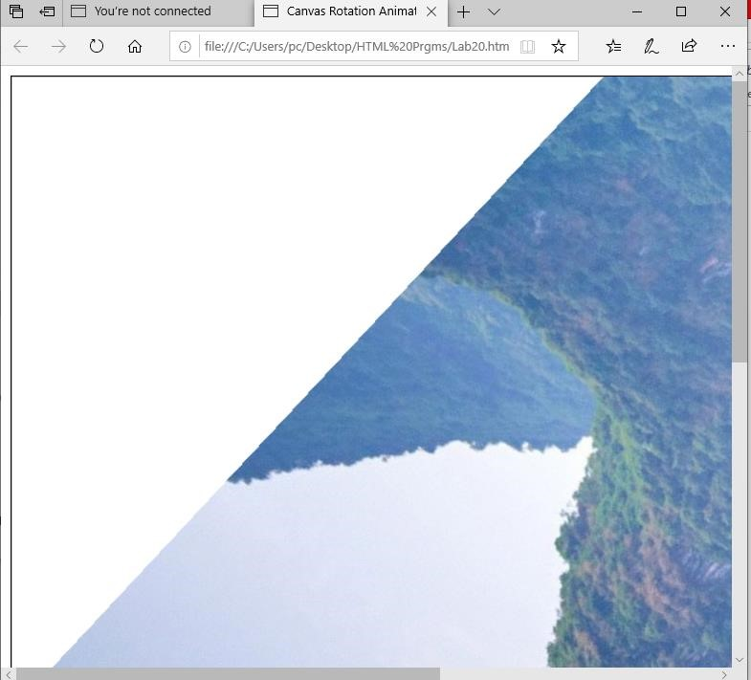

**13)Write a program to draw a star using SVG.**

<!DOCTYPE html>

<html>

<head>

<title>Star using SVG </title>

</head>

<body>

<h2>Star using HTML-5 SVG</h2>

<svg width="100" height="100">

<polygon points="50,10 65,35 100,35 75,60 85,95 50,75 15,95 25,60 0,35 35,35" style="fill:blue;stroke:black;stroke-width:1"/>

</svg>

</body>

</html>

**Output:**

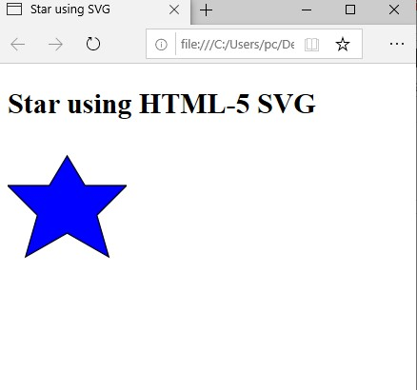

**17)Write a program to rectangle translation.**

<!DOCTYPE html>

<html>

<body>

<h1>HTML5 Canvas</h1>

<h2>The translate() method</h2>

<canvas id="myCanvas" width="300" height="150" style="border:1px solid grey"></canvas>

<script>

const c=document.getElementById("myCanvas"); const ctx=c.getContext("2d");

ctx.fillStyle="red" ctx.fillRect(10,10,100,50); ctx.translate(7,70);

ctx.fillRect(10,10,100,50);

</script>

</body>

</html>

**Output:**

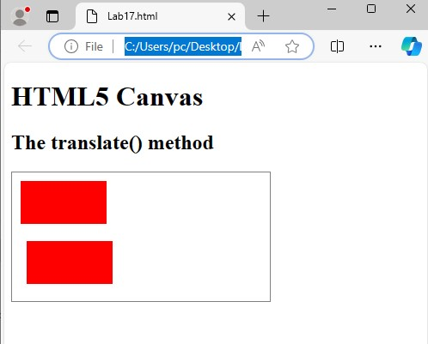

**18)Write a program to rectangle rotation.**

<html>

<body>

<h1>HTML5 Canvas</h1>

<h2>The rotate() method</h2>

<canvas id="myCanvas" width="300" height="150" style="border:1px solid grey"></canvas>

<script>

const c=document.getElementById("myCanvas"); const ctx=c.getContext("2d"); ctx.rotate(20*Math.PI/180);

ctx.fillRect(50,20,100,50);

</script>

</body>

</html>

**Output:**

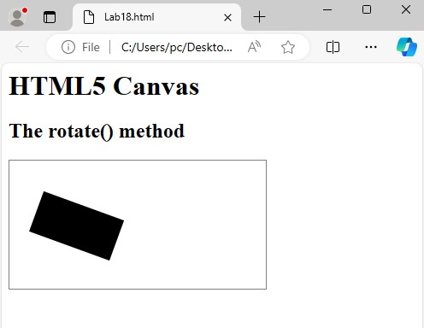

**19)Write a program to rectangle scaling using canvas.**

<html>

<body>

<h1>HTML5 Canvas</h1>

<h2>The scale() method</h2>

<canvas id="myCanvas" width="300" height="150" style="border:1px solid grey"></canvas>

<script>

const c=document.getElementById("myCanvas"); const ctx=c.getContext("2d"); ctx.strokeRect(5,5,25,15);

ctx.scale(3,3);

ctx.strokeRect(5,5,25,15);

</script>

</body>

</html>

**Output:**

